CSIBER Alumni Association
CSIBER Alumni Association is an alumni networking platform with a mission to connect with all alumni, present students by networking with one another to foster a life-long intellectual and emotional connection between the Institute and its graduates. The association serves the need of CSIBER alumni for leadership, voluntary commitment, goodwill, financial support, enhancing industry academic collaboration and communications including public relations.
Alumni Association committee Members
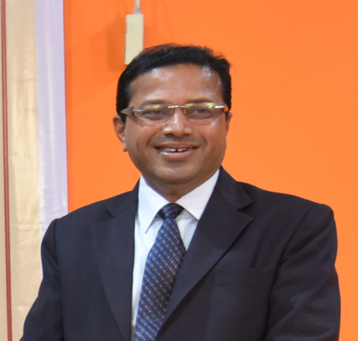 |  | 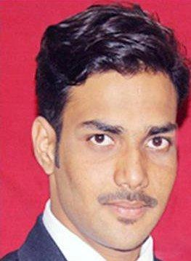
Dr. Umesh M. Deshmukh  President | Udaysingh Mane-Patil  Vice - President | Mr.Raviraj Patil  Secretary.
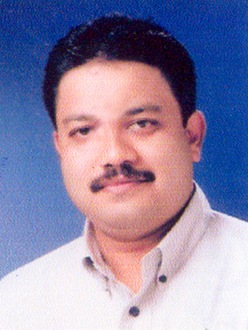 | 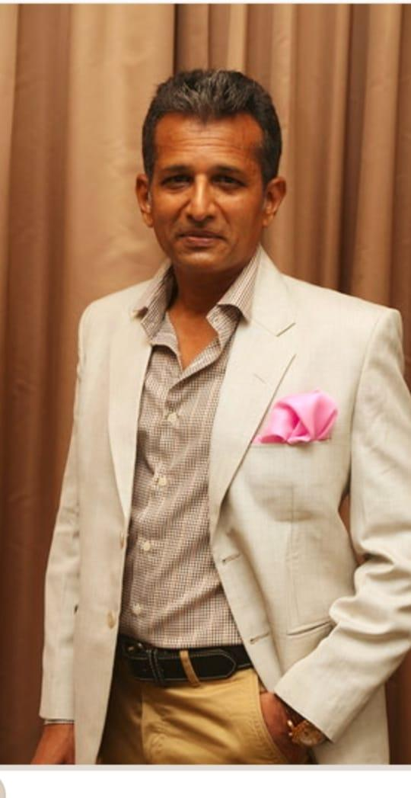 | 
Mr.Ashish Korgaonkar  Member | Mr.Somraj Deshmukh  Member | Miss.Aditi Mulik  Member
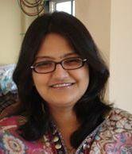
Miss.Nupur Khatodia
Member

Alumni Executive Committee
Dr. Shruti Jamsandekar - Chairperson
Dr. Rajani Kamath – Member
Dr. Bindu Menon – Member
Dr. U. D. Valvi – Member
Rasiya Padalkar – Member
Santosh Hasure – Member

